October 2018

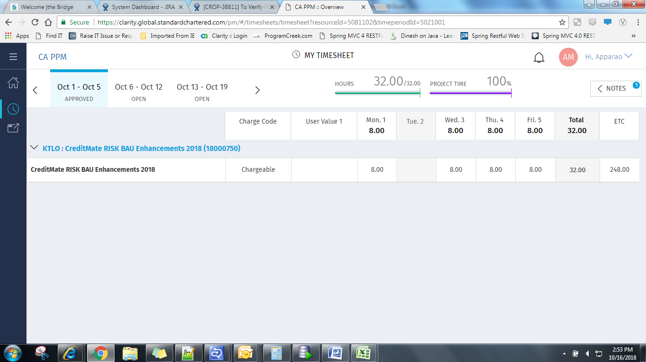
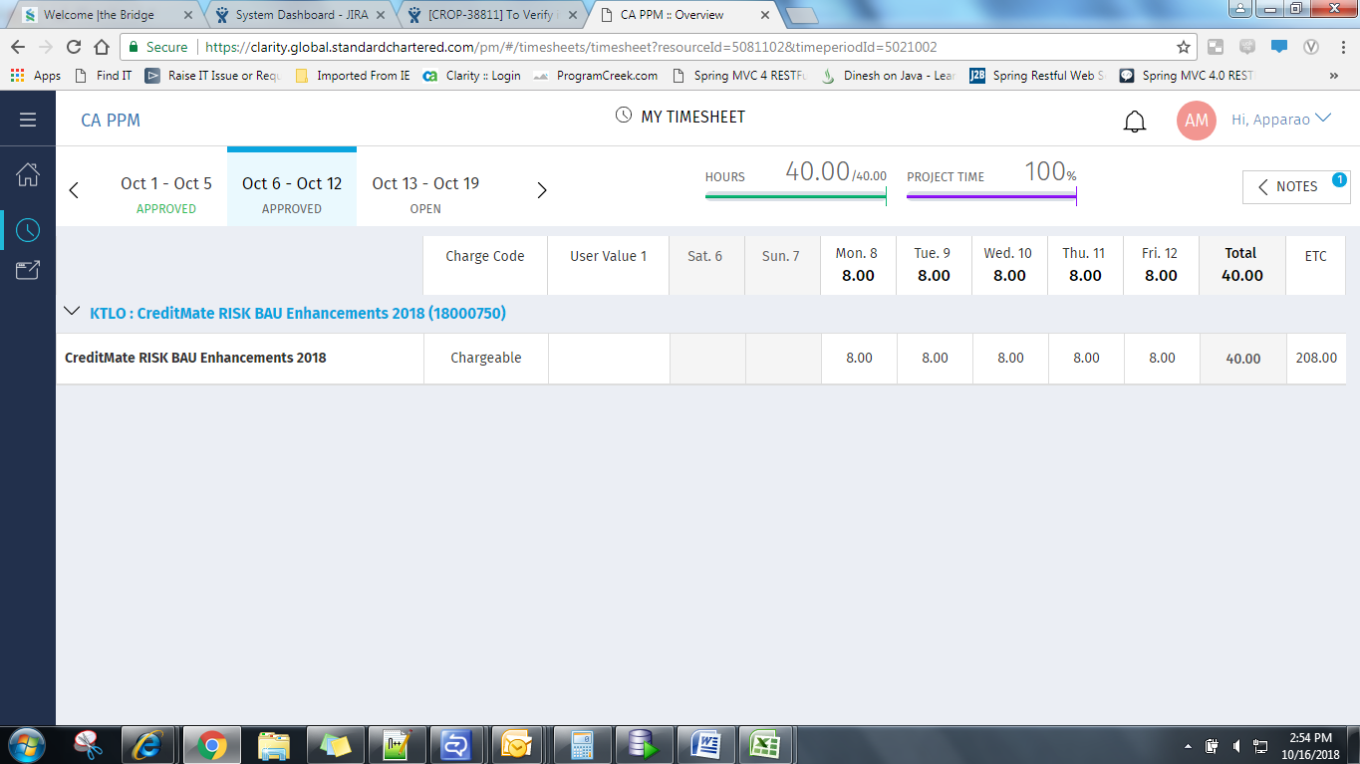
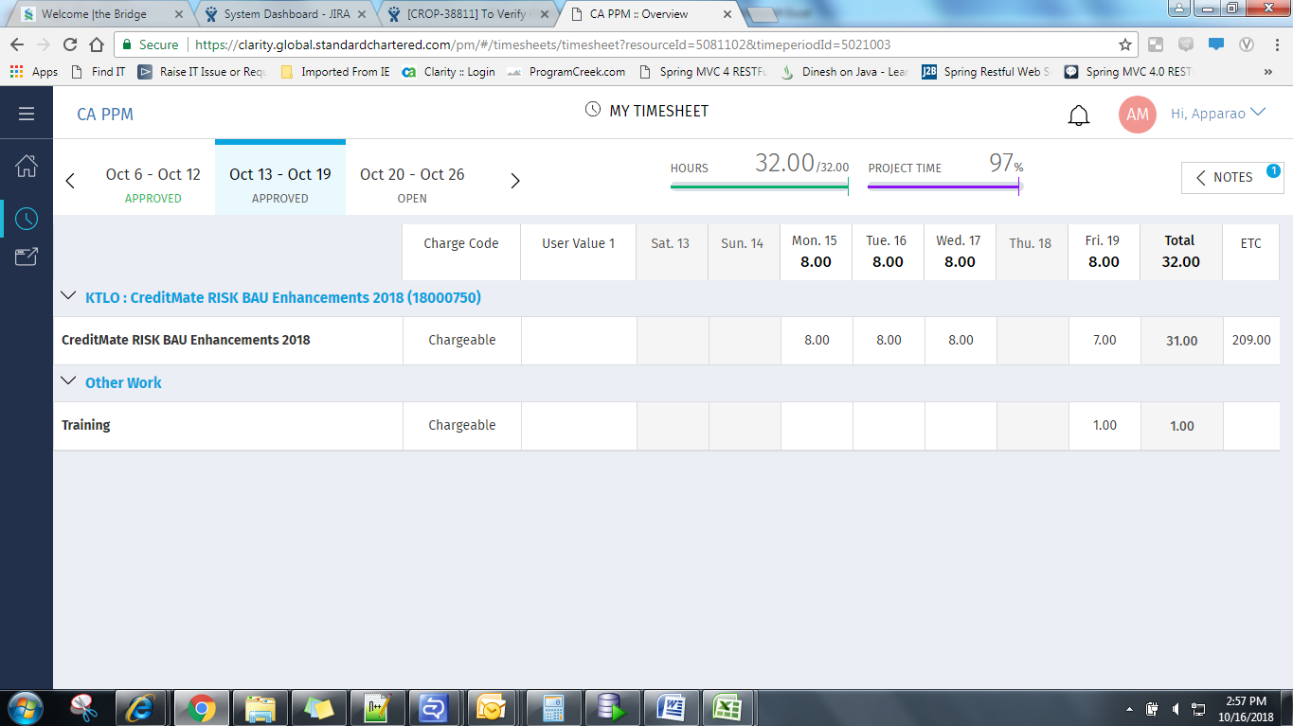
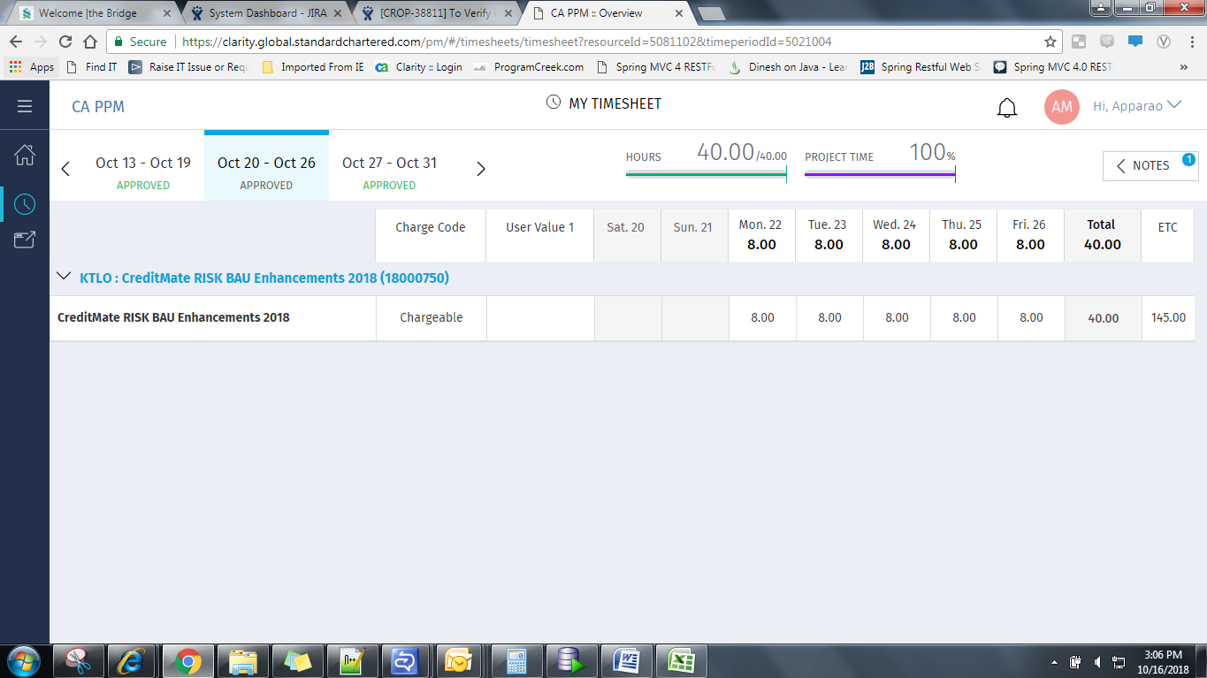
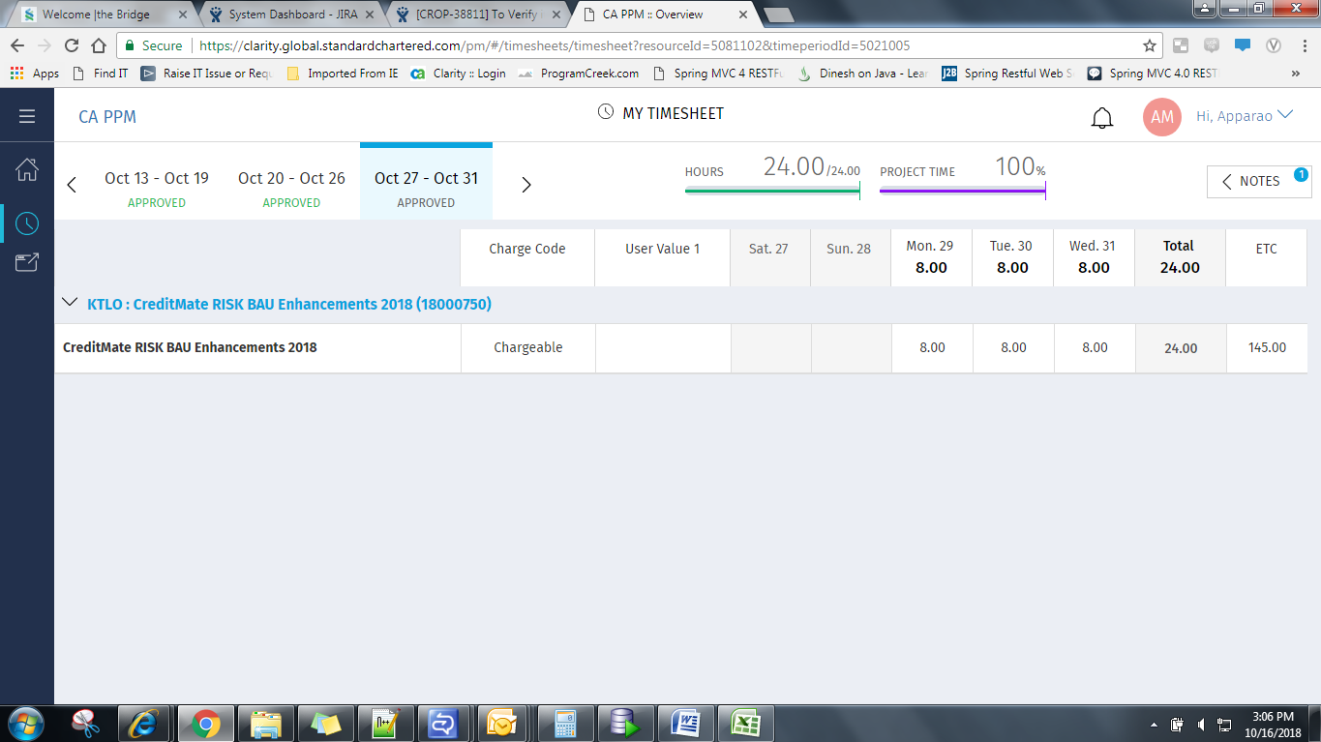

November 2018

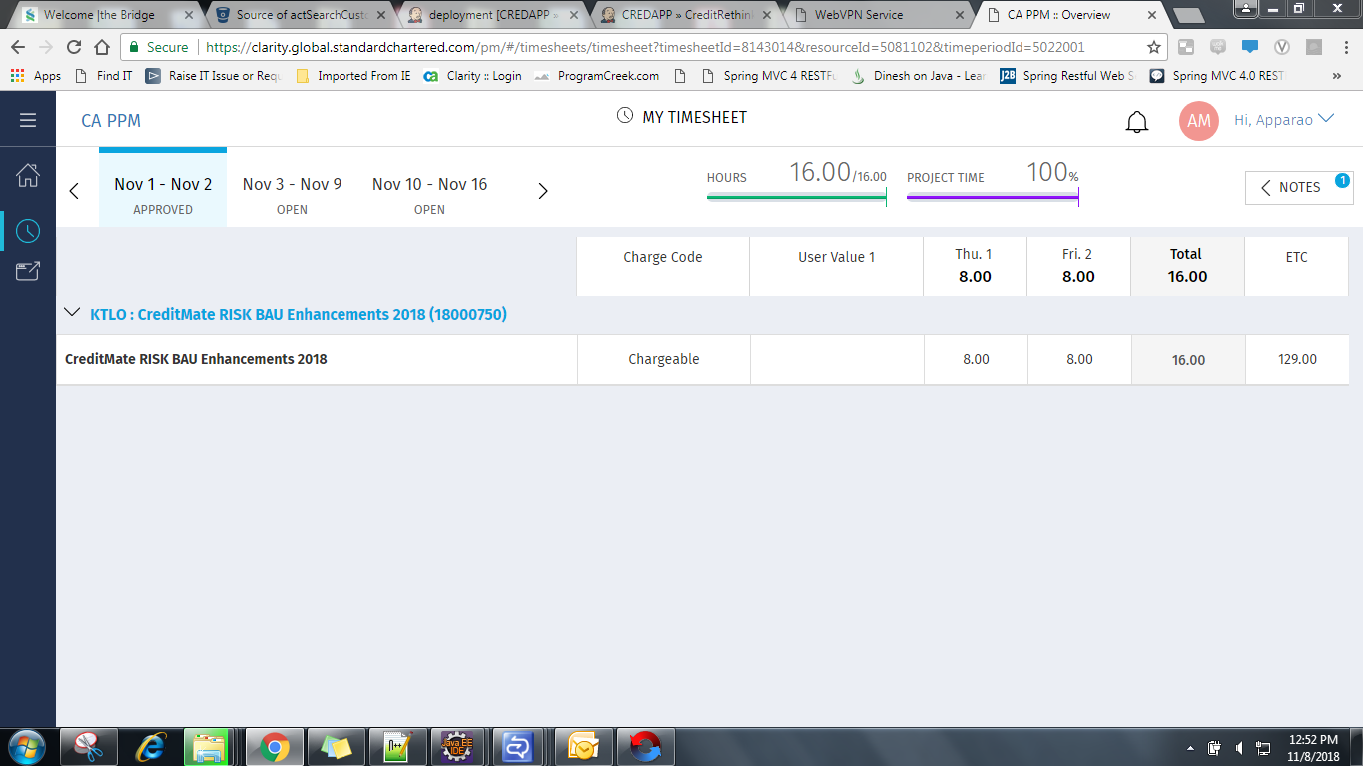
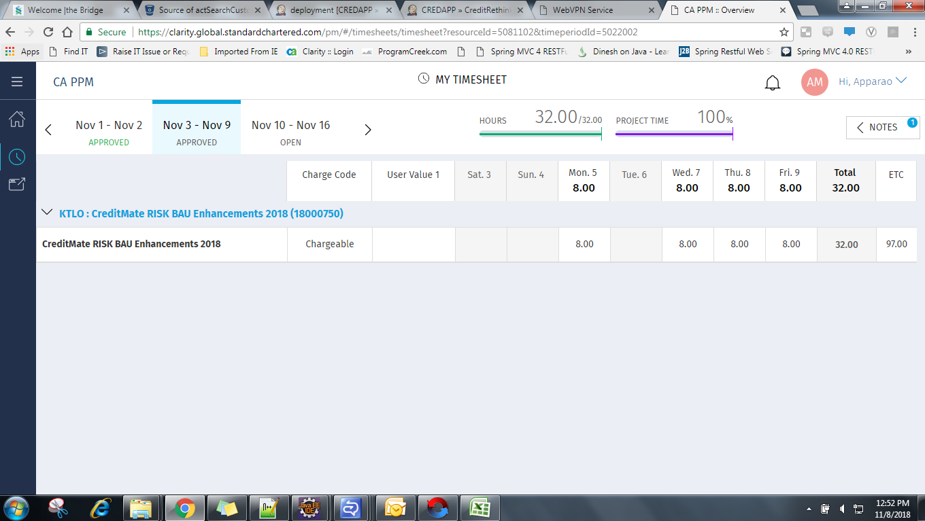
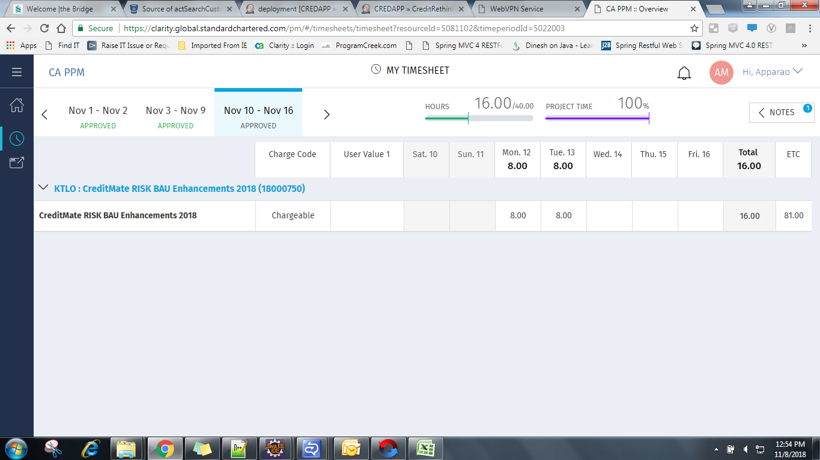
package com.cccc.cr.gter.action.test;

import static org.mockito.Mockito.mock;
import static org.mockito.Mockito.when;

import java.util.ArrayList;
import java.util.HashMap;
import java.util.List;
import java.util.Map;

import javax.servlet.ServletContext;
import javax.servlet.http.HttpServletRequest;
import javax.servlet.http.HttpServletResponse;

import net.sf.ehcache.constructs.web.PageInfo;

import org.apache.struts2.ServletActionContext;
import org.easymock.Mock;
import org.junit.AfterClass;
import org.junit.BeforeClass;
import org.junit.Test;
import org.mockito.Mockito;
import org.springframework.orm.ibatis.SqlMapClientTemplate;
import org.springframework.transaction.annotation.Transactional;

import com.opensymphony.xwork2.Action;
import com.scb.junit.Util.BaseActionTest;
import com.cccc.cr.gter.action.GTERCollateralsAction;
import com.cccc.cr.gter.common.GTERBaseAction;
import com.cccc.cr.gter.common.GTERBaseBean;
import com.cccc.cr.gter.common.GTERConstants;
import com.cccc.cr.gter.dao.GTERListOperationsDAO;
import com.cccc.cr.gter.dao.impl.GTERListOperationsDAOImpl;
import com.cccc.cr.gter.delegate.GTERListOperationsDelegate;
import com.cccc.cr.gter.delegate.impl.GTERListOperationsDelegateImpl;
import com.cccc.cr.gter.model.CustBCAInfoBean;
import com.cccc.cr.gter.model.GTERCollateralsBean;
import com.cccc.cr.gter.model.GTERCollateralsViewBean;
import com.cccc.cr.gter.model.GTERExternalRatingDetails;
import com.cccc.cr.gter.model.GTERHeaderBean;
import com.cccc.cr.gter.model.GrpCustInfoBean;
import com.cccc.cr.inf.action.SessionKeys;
import com.cccc.cr.inf.bo.InfBO;
import com.cccc.cr.inf.dao.SequenceDAO;
import com.cccc.cr.inf.dao.impl.CountryDAOImpl;
import com.cccc.cr.inf.dao.impl.OracleSequenceDAOImpl;
import com.cccc.cr.inf.delegate.InfDelegate;
import com.cccc.cr.inf.delegate.impl.InfDelegateLocalImpl;
import com.cccc.cr.inf.model.CountryMaster;
import com.cccc.cr.inf.model.PageSet;
import com.cccc.cr.inf.model.PagingConfig;
import com.cccc.cr.inf.model.PagingCriteria;
import com.cccc.cr.inf.model.Sequence;
import com.cccc.cr.inf.paging.CachedPagingManager;
import com.cccc.cr.inf.paging.PagingManager;
import com.cccc.cr.inf.service.impl.InfServiceImpl;
import com.cccc.cr.inf.util.CountryUtil;

public class GTERCollateralsActionTest extends BaseActionTest {

private GTERCollateralsBean gterCollateralsBean = null;
private List<GTERCollateralsViewBean> gtercollateralsViewBean = null;

private GTERCollateralsViewBean collateralsViewBean = null;
private GTERListOperationsDelegate gterListOperationsDelegate = null;
private GTERListOperationsDelegateImpl gterListOperationsDelegateImpl = null;
private GTERListOperationsDAOImpl gterListOperationsDAOImpl = null;
private GTERListOperationsDAO gterListOperationsDAO = null;
private GTERCollateralsAction gterCollateralsAction = null;
private GTERCollateralsActionTest gterCollateralsActionTest = null;
private InfDelegate infDelegate = null;

private CountryDAOImpl countryDAOImpl = null;
private InfBO infBO = null;
private InfServiceImpl infServiceImpl = null;
//private CountryMaster countryMaster = null;
private CountryUtil countryUtil = null;
private List collateralTypeList = null;

private List<CountryMaster> countryList = new ArrayList<CountryMaster>();

private List<CountryMaster> sciCountryList = new ArrayList<CountryMaster>();

private SqlMapClientTemplate sqlClientMock = null;
private Object result;
private GTERExternalRatingDetails gterExternalRatingDetails = null;
private GTERBaseAction gterBaseAction = null;
private OracleSequenceDAOImpl oracleSequenceDAOImpl = null;

@Mock
ServletActionContext request;
@Mock
HttpServletRequest httprequest;
@Mock
HttpServletResponse httpresponse;

@BeforeClass
public static void setUpBeforeClass() throws Exception{

}

@AfterClass
public static void tearDownAfterClass() throws Exception{

}

@SuppressWarnings({ "rawtypes", "unchecked", "serial" })
public void setUp() throws Exception{

System.out.println("inside setup");

sqlClientMock = mock(SqlMapClientTemplate.class);
gterListOperationsDAOImpl = new GTERListOperationsDAOImpl();
gterListOperationsDAOImpl.setSqlMapClientTemplate(sqlClientMock);
request=mock(ServletActionContext.class);
httprequest=mock(HttpServletRequest.class);

Map session = null;
request.setSession(session);
request.setRequest(httprequest);

ServletContext servletContext = null;
ServletActionContext.setServletContext(servletContext);

gterCollateralsBean = new GTERCollateralsBean();
gterExternalRatingDetails = new GTERExternalRatingDetails();

gterListOperationsDelegateImpl = new GTERListOperationsDelegateImpl();
gterListOperationsDelegateImpl.setGterListOperationsDAO(gterListOperationsDAOImpl);

infDelegate = new InfDelegateLocalImpl();

countryDAOImpl = new CountryDAOImpl();
countryDAOImpl.setSqlMapClientTemplate(sqlClientMock);
when(sqlClientMock.queryForList(Mockito.eq("getAllCountry"))).thenReturn(getCountry());
when(sqlClientMock.queryForList(Mockito.eq("getSCICountryList"))).thenReturn(getCountry());

infBO = new InfBO();
infBO.setCountryDAO(countryDAOImpl);

infServiceImpl = new InfServiceImpl();
infServiceImpl.setInfBO(infBO);
InfDelegateLocalImpl infDelegateLocalImpl = new InfDelegateLocalImpl();
infDelegateLocalImpl.setService(infServiceImpl);

countryUtil = new CountryUtil(infDelegateLocalImpl);
gterBaseAction = new GTERBaseAction();

PagingManager pagingManager = new CachedPagingManager();
PagingConfig pagingConfig = new PagingConfig();
pagingConfig.setPagesToCache(10);
gterCollateralsAction = new GTERCollateralsAction(gterListOperationsDelegateImpl, countryUtil,pagingManager,pagingConfig)
{
@Override
public String getText(String text)
{
String mock=null;
if(text.equalsIgnoreCase("gter.success.client")){
mock="success";
}
return mock;
}
};

gterCollateralsAction.setServletRequest(httprequest);
gterCollateralsAction.setGterCollateralsBean(gterCollateralsBean);
gterCollateralsAction.setPagingConfig(pagingConfig);

Map actionSessionMap = null;

gterBaseAction.setSession(actionSessionMap);

gterBaseAction.getSession();

buildSession();

System.out.println("outsaid setUP");

}

private List<CountryMaster> getCountry(){

CountryMaster list1 = new CountryMaster();

list1.setCountryId("IN");
list1.setCountryName("INDIA");

List<CountryMaster> lstScorecards=new ArrayList<CountryMaster>();

lstScorecards.add(list1);

return lstScorecards;
}

@Transactional
@Test
public final void testSaveGrpCollImpact() throws Exception{

buildSession();
System.out.println("testSaveGrpCollImpact in ");

when(sqlClientMock.queryForObject(Mockito.eq("updateGrpCollImpactFlag"), Mockito.anyObject())).thenReturn(1);
when(sqlClientMock.queryForObject("getGroupTerCollImpactFlag","690000000727")).thenReturn("690000000727");
when(sqlClientMock.queryForObject(Mockito.eq("checkGrpFacAdditionalDoc"), Mockito.anyObject())).thenReturn(1);

System.out.println("testSaveGrpCollImpact Out ");
final String result = gterCollateralsAction.saveGrpCollImpact();

assertEquals(Action.SUCCESS, result);

}

@Transactional
@Test
public final void testUpdateGrpCollateral() throws Exception{

buildSession();
System.out.println("testUpdateGrpCollateral in ");

List<GTERCollateralsViewBean> ls = new ArrayList<GTERCollateralsViewBean>();
GTERCollateralsViewBean gterCollateralsViewBean1 = new GTERCollateralsViewBean();

gterCollateralsViewBean1.setClntTerReferenceNo("123456");
gterCollateralsViewBean1.setCollateralEditStatus("In-Preparation");
gterCollateralsViewBean1.setBcaRefNum("113276478");

ls.add(gterCollateralsViewBean1);

gterCollateralsBean.setSelectedIndex(10);
gterCollateralsBean.setCollateralList(ls);

gterCollateralsAction.setGtercollateralViewBean(gterCollateralsViewBean1);
gterCollateralsAction.setGterCollateralsBean(gterCollateralsBean);

when(sqlClientMock.queryForObject(Mockito.eq("tercollateral.fsv.user.input"), Mockito.anyMap())).thenReturn("CD");
when(sqlClientMock.queryForList("tercollateral.list.subtype")).thenReturn(ls);
when(sqlClientMock.queryForList("gter.collateral.list.limitsCovered")).thenReturn(ls);
when(sqlClientMock.queryForList("tercollateral.list.type")).thenReturn(ls);

System.out.println("testUpdateGrpCollateral Out ");
final String result = gterCollateralsAction.updateGrpCollateral();

assertEquals(Action.SUCCESS, result);

}

@Transactional
@Test
public final void testDeleteGrpCollateral() throws Exception{

buildSession();
System.out.println("testDeleteGrpCollateral in ");

when(sqlClientMock.queryForObject(Mockito.eq("isLimitsCovGrpFacValid"), Mockito.anyObject())).thenReturn(1);
when(sqlClientMock.queryForObject(Mockito.eq("checkGrpFacAdditionalDoc"), Mockito.anyObject())).thenReturn(1);

System.out.println("testDeleteGrpCollateral Out ");
final String result = gterCollateralsAction.deleteGrpCollateral();
assertEquals(Action.SUCCESS, result);

}

@Transactional
@Test
public final void testDisplayGrpTerCollateralDetails() throws Exception{

buildSession();
System.out.println("testDisplayGrpTerCollateralDetails in ");

List<GTERCollateralsViewBean> ls = new ArrayList<GTERCollateralsViewBean>();
GTERCollateralsViewBean gterCollateralsViewBean1 = new GTERCollateralsViewBean();

gterCollateralsViewBean1.setClntTerReferenceNo("123456");
gterCollateralsViewBean1.setCollateralEditStatus("In-Preparation");
gterCollateralsViewBean1.setBcaRefNum("113276478");

ls.add(gterCollateralsViewBean1);

gterCollateralsBean.setSelectedIndex(10);
gterCollateralsBean.setCollateralList(ls);

gterCollateralsAction.setGtercollateralViewBean(gterCollateralsViewBean1);
gterCollateralsAction.setGterCollateralsBean(gterCollateralsBean);

when(sqlClientMock.queryForObject(Mockito.eq("tercollateral.fsv.user.input"), Mockito.anyMap())).thenReturn("CD");
when(sqlClientMock.queryForList("tercollateral.list.subtype")).thenReturn(ls);
when(sqlClientMock.queryForList("gter.collateral.list.limitsCovered")).thenReturn(ls);
when(sqlClientMock.queryForList("tercollateral.list.type")).thenReturn(ls);

System.out.println("testDisplayGrpTerCollateralDetails Out ");
final String result = gterCollateralsAction.displayGrpTerCollateralDetails();
assertEquals(Action.SUCCESS, result);

}

@Transactional
@Test
public final void testGetGrpCollateralSubTypeList() throws Exception{

buildSession();
System.out.println("testGetGrpCollateralSubTypeList in ");

when(request.getRequest()).thenReturn(httprequest);
when(request.getRequest().getParameter("collateralType")).thenReturn("BCA");

System.out.println("testGetGrpCollateralSubTypeList Out ");
final String result = gterCollateralsAction.getGrpCollateralSubTypeList();
assertEquals(Action.SUCCESS, result);

}

@Transactional
@Test
public final void testAddRatingToGrpCollateral() throws Exception{

buildSession();
System.out.println("testAddRatingToGrpCollateral in ");

List<GTERCollateralsViewBean> ls = new ArrayList<GTERCollateralsViewBean>();
GTERCollateralsViewBean gterCollateralsViewBean1 = new GTERCollateralsViewBean();

gterCollateralsViewBean1.setClntTerReferenceNo("123456");
gterCollateralsViewBean1.setCollateralEditStatus("In-Preparation");
gterCollateralsViewBean1.setBcaRefNum("113276478");
gterCollateralsViewBean1.setCollateralType("collateralType");
gterCollateralsViewBean1.setCreating(true);

ls.add(gterCollateralsViewBean1);

gterCollateralsBean.setSelectedIndex(10);
gterCollateralsBean.setCollateralList(ls);
gterCollateralsBean.setDetailedCollateral(gterCollateralsViewBean1);

gterCollateralsAction.setGtercollateralViewBean(gterCollateralsViewBean1);
gterCollateralsAction.setGterCollateralsBean(gterCollateralsBean);

when(sqlClientMock.queryForList("tercollateral.list.subtype")).thenReturn(ls);

System.out.println("testAddRatingToGrpCollateral Out ");
final String result = gterCollateralsAction.addRatingToGrpCollateral();
assertEquals(Action.SUCCESS, result);

}

@Transactional
@Test
public final void testUpdateGrpCollateralRating() throws Exception{

buildSession();
System.out.println("testUpdateGrpCollateralRating in ");

List<GTERExternalRatingDetails> ls1 = new ArrayList<GTERExternalRatingDetails>();
GTERExternalRatingDetails gterExternalRatingDetails1 = new GTERExternalRatingDetails();

ls1.add(gterExternalRatingDetails1);

List<GTERCollateralsViewBean> ls = new ArrayList<GTERCollateralsViewBean>();
GTERCollateralsViewBean gterCollateralsViewBean1 = new GTERCollateralsViewBean();

gterCollateralsViewBean1.setClntTerReferenceNo("123456");
gterCollateralsViewBean1.setCollateralEditStatus("In-Preparation");
gterCollateralsViewBean1.setBcaRefNum("113276478");
gterCollateralsViewBean1.setCollateralType("collateralType");

gterCollateralsViewBean1.setExternalRatingDetails(ls1);

ls.add(gterCollateralsViewBean1);

gterCollateralsBean.setSelectedIndex(10);
gterCollateralsBean.setCollateralList(ls);
gterCollateralsBean.setDetailedCollateral(gterCollateralsViewBean1);

gterCollateralsAction.setGtercollateralViewBean(gterCollateralsViewBean1);
gterCollateralsAction.setGterCollateralsBean(gterCollateralsBean);

when(sqlClientMock.queryForObject(Mockito.eq("tercollateral.fsv.user.input"), Mockito.anyMap())).thenReturn("CD");
when(sqlClientMock.queryForList("tercollateral.list.subtype")).thenReturn(ls);

System.out.println("testUpdateGrpCollateralRating Out ");
final String result = gterCollateralsAction.updateGrpCollateralRating();
assertEquals(Action.SUCCESS, result);

}

@Transactional
@Test
public final void testGeleteRatingFromGrpCollateral() throws Exception{

buildSession();
System.out.println("testGeleteRatingFromGrpCollateral in ");

List<GTERExternalRatingDetails> ls1 = new ArrayList<GTERExternalRatingDetails>();
GTERExternalRatingDetails gterExternalRatingDetails1 = new GTERExternalRatingDetails();
ls1.add(gterExternalRatingDetails1);
List<GTERCollateralsViewBean> ls = new ArrayList<GTERCollateralsViewBean>();
GTERCollateralsViewBean gterCollateralsViewBean1 = new GTERCollateralsViewBean();
gterCollateralsViewBean1.setClntTerReferenceNo("123456");
gterCollateralsViewBean1.setCollateralEditStatus("In-Preparation");
gterCollateralsViewBean1.setBcaRefNum("113276478");
gterCollateralsViewBean1.setCollateralType("collateralType");
gterCollateralsViewBean1.setExternalRatingDetails(ls1);
ls.add(gterCollateralsViewBean1);

gterCollateralsBean.setSelectedIndex(10);
gterCollateralsBean.setCollateralList(ls);
gterCollateralsBean.setDetailedCollateral(gterCollateralsViewBean1);

gterCollateralsAction.setGtercollateralViewBean(gterCollateralsViewBean1);
gterCollateralsAction.setGterCollateralsBean(gterCollateralsBean);

System.out.println("testGeleteRatingFromGrpCollateral Out ");
final String result = gterCollateralsAction.deleteRatingFromGrpCollateral();
assertEquals(Action.SUCCESS, result);

}

@Transactional
@Test
public final void testSaveRatingToGrpCollateral() throws Exception{

buildSession();
System.out.println("testSaveRatingToGrpCollateral in ");

List<GTERExternalRatingDetails> ls1 = new ArrayList<GTERExternalRatingDetails>();
GTERExternalRatingDetails gterExternalRatingDetails1 = new GTERExternalRatingDetails();
gterExternalRatingDetails1.setExternalRatingAgency("externalRatingAgency");
gterExternalRatingDetails1.setExtRatingAgencyType("extRatingAgencyType");
gterExternalRatingDetails1.setDateofExternalRating("10/2017");
ls1.add(gterExternalRatingDetails1);

List<GTERCollateralsViewBean> ls = new ArrayList<GTERCollateralsViewBean>();
GTERCollateralsViewBean gterCollateralsViewBean1 = new GTERCollateralsViewBean();
gterCollateralsViewBean1.setClntTerReferenceNo("123456");
gterCollateralsViewBean1.setCollateralEditStatus("In-Preparation");
gterCollateralsViewBean1.setBcaRefNum("113276478");
gterCollateralsViewBean1.setCollateralType("collateralType");
ls.add(gterCollateralsViewBean1);

gterCollateralsBean.setSelectedIndex(10);
gterCollateralsBean.setCollateralList(ls);
gterCollateralsBean.setDetailedRating(gterExternalRatingDetails1);
gterCollateralsBean.setDetailedCollateral(gterCollateralsViewBean1);
gterCollateralsViewBean1.setExternalRatingDetails(ls1);

gterCollateralsAction.setGtercollateralViewBean(gterCollateralsViewBean1);
gterCollateralsAction.setGterCollateralsBean(gterCollateralsBean);

when(sqlClientMock.queryForObject(Mockito.eq("tercollateral.fsv.user.input"), Mockito.anyMap())).thenReturn("CD");
when(sqlClientMock.queryForList("tercollateral.list.subtype")).thenReturn(ls);

System.out.println("testSaveRatingToGrpCollateral Out ");
final String result = gterCollateralsAction.saveRatingToGrpCollateral();
assertEquals(Action.SUCCESS, result);

}

@Transactional
@Test
public final void testSaveUpdatedGrpCollateralRating() throws Exception{

buildSession();
System.out.println("testSaveUpdatedGrpCollateralRating in ");

List<GTERExternalRatingDetails> ls1 = new ArrayList<GTERExternalRatingDetails>();
GTERExternalRatingDetails gterExternalRatingDetails1 = new GTERExternalRatingDetails();
gterExternalRatingDetails1.setExternalRatingAgency("externalRatingAgency");
gterExternalRatingDetails1.setExtRatingAgencyType("extRatingAgencyType");
gterExternalRatingDetails1.setDateofExternalRating("10/2017");
ls1.add(gterExternalRatingDetails1);

List<GTERCollateralsViewBean> ls = new ArrayList<GTERCollateralsViewBean>();
GTERCollateralsViewBean gterCollateralsViewBean1 = new GTERCollateralsViewBean();
gterCollateralsViewBean1.setClntTerReferenceNo("123456");
gterCollateralsViewBean1.setCollateralEditStatus("In-Preparation");
gterCollateralsViewBean1.setBcaRefNum("113276478");
gterCollateralsViewBean1.setCollateralType("collateralType");
gterCollateralsViewBean1.setExternalRatingDetails(ls1);

ls.add(gterCollateralsViewBean1);

gterCollateralsBean.setSelectedIndex(10);
gterCollateralsBean.setCollateralList(ls);
gterCollateralsBean.setDetailedRating(gterExternalRatingDetails1);
gterCollateralsBean.setDetailedCollateral(gterCollateralsViewBean1);
gterCollateralsViewBean1.setExternalRatingDetails(ls1);

gterCollateralsAction.setGtercollateralViewBean(gterCollateralsViewBean1);
gterCollateralsAction.setGterCollateralsBean(gterCollateralsBean);

when(sqlClientMock.queryForObject(Mockito.eq("tercollateral.fsv.user.input"), Mockito.anyMap())).thenReturn("CD");
when(sqlClientMock.queryForList("tercollateral.list.subtype")).thenReturn(ls);

System.out.println("testSaveUpdatedGrpCollateralRating Out ");
final String result = gterCollateralsAction.saveUpdatedGrpCollateralRating();
assertEquals(Action.SUCCESS, result);

}

@Transactional
@Test
public final void testGetGrpExternalRatingListData() throws Exception{

buildSession();
System.out.println("testGetGrpExternalRatingListData in ");

List<GTERCollateralsViewBean> ls = new ArrayList<GTERCollateralsViewBean>();
GTERCollateralsViewBean gterCollateralsViewBean1 = new GTERCollateralsViewBean();

gterCollateralsViewBean1.setClntTerReferenceNo("123456");
gterCollateralsViewBean1.setCollateralEditStatus("In-Preparation");
gterCollateralsViewBean1.setBcaRefNum("113276478");
gterCollateralsViewBean1.setCollateralType("collateralType");

ls.add(gterCollateralsViewBean1);

gterCollateralsBean.setSelectedIndex(10);
gterCollateralsBean.setCollateralList(ls);
gterCollateralsBean.setDetailedCollateral(gterCollateralsViewBean1);

gterCollateralsAction.setGtercollateralViewBean(gterCollateralsViewBean1);
gterCollateralsAction.setGterCollateralsBean(gterCollateralsBean);

when(sqlClientMock.queryForObject(Mockito.eq("grpTercollateral.rating.tableReference"), Mockito.anyMap())).thenReturn("CD");
when(sqlClientMock.queryForList("grpTercollateral.list.ratings")).thenReturn(ls);

System.out.println("testGetGrpExternalRatingListData Out ");
final String result = gterCollateralsAction.getGrpExternalRatingListData();
assertEquals(Action.SUCCESS, result);

}

@Transactional
@Test
public final void testSaveUpdatedGrpCollateral() throws Exception{

buildSession();
System.out.println("testSaveUpdatedGrpCollateral in ");

GTERBaseBean gterBaseBean1 = new GTERHeaderBean();
List<GTERBaseBean> gal1 = new ArrayList<GTERBaseBean>();
gal1.add(gterBaseBean1);

List<GTERExternalRatingDetails> ls1 = new ArrayList<GTERExternalRatingDetails>();
GTERExternalRatingDetails gterExternalRatingDetails1 = new GTERExternalRatingDetails();
gterExternalRatingDetails1.setExternalRatingAgency("externalRatingAgency");
gterExternalRatingDetails1.setExtRatingAgencyType("extRatingAgencyType");
gterExternalRatingDetails1.setDateofExternalRating("10/2017");

gterExternalRatingDetails1.setExternalRatingId("extRatingId");
gterExternalRatingDetails1.setScreenId("screenID");
gterExternalRatingDetails1.setExternalRatingParentId("extRatingTypeId");
gterExternalRatingDetails1.setDateOfLastChange("dateOfLastChange");
gterExternalRatingDetails1.setDateOfOutlookAssigned("dateOfOutlookAssigned");
gterExternalRatingDetails1.setDirectionLastChange("directionLastChange");
gterExternalRatingDetails1.setPresentOutlook("presentOutlook");
gterExternalRatingDetails1.setBankFinanceStrengthRating("bankFinanceStrengthRating");
gterExternalRatingDetails1.setBcaRefNum("563750");
gterExternalRatingDetails1.setExternalRatingParentName("externalRatingParentName");
gterExternalRatingDetails1.setExtRatdetailsAddedAtInPrepLevel("extRatdetailsAddedAtInPrepLevel");
gterExternalRatingDetails1.setClntTerReferenceNo("567849");

gterExternalRatingDetails1.getExternalRatingId();
gterExternalRatingDetails1.getScreenId();
gterExternalRatingDetails1.getExternalRatingParentId();
gterExternalRatingDetails1.getDateOfLastChange();
gterExternalRatingDetails1.getDateOfOutlookAssigned();
gterExternalRatingDetails1.getDirectionLastChange();
gterExternalRatingDetails1.getPresentOutlook();
gterExternalRatingDetails1.getBankFinanceStrengthRating();
gterExternalRatingDetails1.getBcaRefNum();
gterExternalRatingDetails1.getExternalRatingParentName();
gterExternalRatingDetails1.getExtRatdetailsAddedAtInPrepLevel();
gterExternalRatingDetails1.getClntTerReferenceNo();
gterExternalRatingDetails1.getChildBeanClass("childKey");
gterExternalRatingDetails1.getChildKeys();
gterExternalRatingDetails1.getChildList("childKey");
gterExternalRatingDetails1.setChildList(gal1);

ls1.add(gterExternalRatingDetails1);

List<GTERCollateralsViewBean> ls = new ArrayList<GTERCollateralsViewBean>();
GTERCollateralsViewBean gterCollateralsViewBean1 = new GTERCollateralsViewBean();
gterCollateralsViewBean1.setClntTerReferenceNo("123456");
gterCollateralsViewBean1.setCollateralEditStatus("D");
gterCollateralsViewBean1.setBcaRefNum("113276478");
gterCollateralsViewBean1.setCollateralType("collateralType");
gterCollateralsViewBean1.setGenSpecType("genSpecType");
gterCollateralsViewBean1.setCollateralSubType("collateralSubType");
gterCollateralsViewBean1.setCcy("e");
gterCollateralsViewBean1.setCollateralLocation("collateralLocation");
gterCollateralsViewBean1.setCollateralOwnByThirdParty("collateralOwnByThirdParty");
gterCollateralsViewBean1.setCmv("Cmv");
gterCollateralsViewBean1.setCollateralClaim("collateralClaim");

ls.add(gterCollateralsViewBean1);

gterCollateralsBean.setSelectedIndex(0);
gterCollateralsBean.setCollateralList(ls);
gterCollateralsBean.setDetailedRating(gterExternalRatingDetails1);
gterCollateralsBean.setDetailedCollateral(gterCollateralsViewBean1);

gterCollateralsViewBean1.setExternalRatingDetails(ls1);

gterCollateralsAction.setGtercollateralViewBean(gterCollateralsViewBean1);
gterCollateralsAction.setGterCollateralsBean(gterCollateralsBean);

when(sqlClientMock.queryForObject(Mockito.eq("gtercollateral.fsv.margin"), Mockito.anyMap())).thenReturn("e");
when(sqlClientMock.queryForObject(Mockito.eq("tercollateral.fsv.user.input"), Mockito.anyMap())).thenReturn("e");
when(sqlClientMock.queryForList("tercollateral.list.subtype")).thenReturn(ls);
when(sqlClientMock.queryForObject(Mockito.eq("checkGrpFacAdditionalDoc"), Mockito.anyObject())).thenReturn(1);
when(sqlClientMock.queryForObject(Mockito.eq("tercollateral.fsv.user.input"), Mockito.anyMap())).thenReturn("D");
when(sqlClientMock.queryForList("tercollateral.list.subtype")).thenReturn(ls);

when(sqlClientMock.queryForObject(Mockito.eq("isLimitsCovGrpFacValid"), Mockito.anyObject())).thenReturn(1);
when(sqlClientMock.queryForObject("getGroupTerCollImpactFlag","690000000727")).thenReturn("Yes");
when(sqlClientMock.queryForList(Mockito.eq("selectQueryId"))).thenReturn(ls);

when(sqlClientMock.queryForList(Mockito.eq("getBcaGrpCollaterals"))).thenReturn(ls);
when(sqlClientMock.queryForList(Mockito.eq("getOldCollateralList"))).thenReturn(ls);

System.out.println("testSaveUpdatedGrpCollateral Out ");
final String result = gterCollateralsAction.saveUpdatedGrpCollateral();
assertEquals(Action.SUCCESS, result);

}

private HashMap getMap(){
HashMap map = new HashMap();
map.put("rfaRefno", "60000131");
return map;
}

private HashMap getMap1(){

ArrayList al1 = new ArrayList();
al1.add(1);

ArrayList al2 = new ArrayList();
al2.add(2);

List al = new ArrayList();
al.add(al1);
al.add(al2);

GTERBaseAction gterBaseActionPage = new GTERBaseAction();
PageSet ps = new PageSet();
ps.setPageList(al);
HashMap map = new HashMap();
map.put(SessionKeys.GTER_COLL_RESULT_PAGESET,ps);
return map;
}

@Transactional
@Test
public final void testGetGrpCollateralFsvMargin() throws Exception{

buildSession();
System.out.println("testGetGrpCollateralFsvMargin in ");

List<GTERCollateralsViewBean> ls = new ArrayList<GTERCollateralsViewBean>();
GTERCollateralsViewBean gterCollateralsViewBean1 = new GTERCollateralsViewBean();
gterCollateralsViewBean1.setClntTerReferenceNo("123456");

ls.add(gterCollateralsViewBean1);

when(request.getRequest()).thenReturn(httprequest);
when(request.getRequest().getParameter("collateralType")).thenReturn("collateralType");
when(request.getRequest().getParameter("collateralSubType")).thenReturn("collateralSubType");
when(request.getRequest().getParameter("collateralLocation")).thenReturn("collateralLocation");
when(request.getRequest().getParameter("collBcaRefNum")).thenReturn("collBcaRefNum");
when(request.getRequest().getParameter("clntTerRefNum")).thenReturn("clntTerRefNum");
when(request.getRequest().getParameter("currency")).thenReturn("currency");
when(request.getRequest().getParameter("selLimits")).thenReturn("selLimits");

when(sqlClientMock.queryForObject(Mockito.eq("getGrpTerHairCutMargin"), Mockito.anyMap())).thenReturn("abc");
when(sqlClientMock.queryForList("gtercollateral.list.limitsCoveredCurrency")).thenReturn(ls);
when(sqlClientMock.queryForObject(Mockito.eq("gtercollateral.fsv.margin"), Mockito.anyMap())).thenReturn("e");
when(sqlClientMock.queryForObject(Mockito.eq("checkGrpFacAdditionalDoc"), Mockito.anyObject())).thenReturn(1);
when(sqlClientMock.queryForObject(Mockito.eq("tercollateral.fsv.user.input"), Mockito.anyMap())).thenReturn("D");

System.out.println("testGetGrpCollateralFsvMargin Out ");
final String result = gterCollateralsAction.getGrpCollateralFsvMargin();
assertEquals(Action.SUCCESS, result);

}

@Transactional
@Test
public final void testSaveAllGrpCollaterals() throws Exception{

buildSession();
System.out.println("testSaveAllGrpCollaterals in ");

when(sqlClientMock.queryForObject(Mockito.eq("updateGrpCollImpactFlag"), Mockito.anyObject())).thenReturn(1);
when(sqlClientMock.queryForObject("getGroupTerCollImpactFlag","690000000727")).thenReturn("690000000727");
when(sqlClientMock.queryForObject(Mockito.eq("checkGrpFacAdditionalDoc"), Mockito.anyObject())).thenReturn(1);

System.out.println("testSaveAllGrpCollaterals Out ");
try{
final String result = gterCollateralsAction.saveAllGrpCollaterals();
if(result !=null)
assertEquals(Action.SUCCESS, result);
}
catch(Exception e){
}

}

@Transactional
@Test
public final void testAddGrpCollateralDetail() throws Exception{

buildSession();
System.out.println("testAddGrpCollateralDetail in ");

List<GTERCollateralsViewBean> ls = new ArrayList<GTERCollateralsViewBean>();
GTERCollateralsViewBean gterCollateralsViewBean1 = new GTERCollateralsViewBean();

gterCollateralsViewBean1.setClntTerReferenceNo("123456");
gterCollateralsViewBean1.setCollateralEditStatus("In-Preparation");
gterCollateralsViewBean1.setBcaRefNum("113276478");

ls.add(gterCollateralsViewBean1);

gterCollateralsBean.setSelectedIndex(10);
gterCollateralsBean.setCollateralList(ls);
gterCollateralsBean.setOldCollateralDetailsList(ls);

gterCollateralsAction.setGtercollateralViewBean(gterCollateralsViewBean1);
gterCollateralsAction.setGterCollateralsBean(gterCollateralsBean);

when(sqlClientMock.queryForObject(Mockito.eq("isLimitsCovGrpFacValid"), Mockito.anyObject())).thenReturn(1);
when(sqlClientMock.queryForObject(Mockito.eq("checkGrpFacAdditionalDoc"), Mockito.anyObject())).thenReturn(1);
when(sqlClientMock.queryForObject("getGroupTerCollImpactFlag","690000000727")).thenReturn("Yes");
when(sqlClientMock.queryForList(Mockito.eq("selectQueryId"))).thenReturn(ls);
when(sqlClientMock.queryForObject(Mockito.eq("checkGrpFacAdditionalDoc"), Mockito.anyObject())).thenReturn(1);
when(sqlClientMock.queryForList(Mockito.eq("getBcaGrpCollaterals"))).thenReturn(ls);
when(sqlClientMock.queryForList(Mockito.eq("getOldCollateralList"))).thenReturn(ls);

System.out.println("testAddGrpCollateralDetail Out ");
final String result = gterCollateralsAction.addGrpCollateralDetail();
assertEquals(Action.SUCCESS, result);

}

@Transactional
@Test
public final void testHideGrpCollateralDetails() throws Exception{

buildSession();
System.out.println("testHideGrpCollateralDetails in ");

PageSet ps = new PageSet();
PagingCriteria pagingCriteria = new PagingCriteria();
PagingManager pagingManager1 = new CachedPagingManager();
PagingConfig pagingConfig1 = new PagingConfig();
SequenceDAO sequenceDAO = new OracleSequenceDAOImpl();

List<GrpCustInfoBean> ls = new ArrayList<GrpCustInfoBean>();

GrpCustInfoBean grpCustInfoBean = new GrpCustInfoBean();
grpCustInfoBean.setCustomerName("GRP NAME 990059073");
grpCustInfoBean.setLeid("990059073");
ls.add(grpCustInfoBean);

gterCollateralsAction.setPageColleditId(7654317);
gterCollateralsAction.setPageCollId(1234);
gterCollateralsAction.setCollateralsResultsPageSet(ps);
gterCollateralsAction.setTotalCollaterals(2345);
gterCollateralsAction.setPagingCriteria(pagingCriteria);
gterCollateralsAction.setGrpCustInfoBeans(ls);
gterCollateralsAction.setTotalRecords(124);
gterCollateralsAction.setPagingManager(pagingManager1);
gterCollateralsAction.setSortColumn("sortColumn");
gterCollateralsAction.setSortDirection("sortDirection");
gterCollateralsAction.setPagingConfig(pagingConfig1);
gterCollateralsAction.setBcaCustResultsPageSet(ps);
gterCollateralsAction.setSequenceDAO(sequenceDAO);
gterCollateralsAction.setGroupTerDelegate(gterListOperationsDelegate);
gterCollateralsAction.setCountryUtil(countryUtil);
gterCollateralsAction.setLimitCoveredList(ls);
gterCollateralsAction.setEntitiesCoveredList(ls);
gterCollateralsAction.setCollateralTypeList(ls);
gterCollateralsAction.setCollateralSubTypeLov(ls);
gterCollateralsAction.setEra("era");
gterCollateralsAction.setFcrLtList(ls);

gterCollateralsAction.getPageId();
gterCollateralsAction.getPageColleditId();
gterCollateralsAction.getPageCollId();
gterCollateralsAction.getCollateralsResultsPageSet();
gterCollateralsAction.getTotalCollaterals();
gterCollateralsAction.getPagingCriteria();
gterCollateralsAction.getGrpCustInfoBeans();
gterCollateralsAction.getTotalRecords();
gterCollateralsAction.getPagingManager();
gterCollateralsAction.getSortColumn();
gterCollateralsAction.getSortDirection();
gterCollateralsAction.getPagingConfig();
gterCollateralsAction.getBcaCustResultsPageSet();
gterCollateralsAction.getGroupTerDelegate();
gterCollateralsAction.getCountryUtil();
gterCollateralsAction.getLimitCoveredList();
gterCollateralsAction.getEntitiesCoveredList();
gterCollateralsAction.getCollateralTypeList();
gterCollateralsAction.getCollateralSubTypeLov();
gterCollateralsAction.getGtercollateralViewBean();
gterCollateralsAction.getEra();
gterCollateralsAction.getFcrLtList();

GTERHeaderBean gterBaseBean1 = new GTERHeaderBean();
gterBaseBean1.setGroupSegment("groupSegment");
gterBaseBean1.setLockedBy("lockedBy");
gterBaseBean1.setGroupSubSegment("groupSubSegment");
gterBaseBean1.setGroupName("groupName");
gterBaseBean1.setGroupGamName("groupGamName");
gterBaseBean1.setGroupGamCode("groupGamCode");
gterBaseBean1.setDocStatus("docStatus");
gterBaseBean1.setAuthorId(1524504);
gterBaseBean1.setAuthorName("authorName");
gterBaseBean1.setOuterLimitId(1000);
gterBaseBean1.setSecurityCMV(1000);
gterBaseBean1.setSecurityFSV(1324);
gterBaseBean1.setScurityComments("scurityComments");
gterBaseBean1.setFinalizeDate("10/07/2018");
gterBaseBean1.setCobImpactl("cobImpactl");
gterBaseBean1.setCollImpact("collImpact");
gterBaseBean1.setCancelFlag("cancelFlag");
gterBaseBean1.setCreateFromRmwb("createFromRmwb");
gterBaseBean1.setGroupCatagery("groupCatagery");
gterBaseBean1.setSegSubClassification("segSubClassification");
gterBaseBean1.setCrCustCmpId("crCustCmpId");
gterBaseBean1.setLastModifiedDate("lastModifiedDate");
gterBaseBean1.setCreatedDate("createdDate");
gterBaseBean1.setCustId(11772474);
gterBaseBean1.setGterLockedBy(1);
gterBaseBean1.setGterFinalize("gterFinalize");
Integer i = 100;
gterBaseBean1.setOldGTERRef(i);
gterBaseBean1.setCmpId(200);
gterBaseBean1.setDocId("docId");
gterBaseBean1.setLockedByOtherUser(true);
gterBaseBean1.setLockedByOtherSession(true);
gterBaseBean1.setMode("mode");
gterBaseBean1.setLoginId("loginId");
gterBaseBean1.setDocLocked(true);
gterBaseBean1.setProposeLockFlag("proposeLockFlag");
gterBaseBean1.setBcaReferenceNo("bcaReferenceNo");
gterBaseBean1.setGterLocakPropose(i);
gterBaseBean1.setGterFinalized("gterFinalized");
gterBaseBean1.setRollOutFlagCCCICPhase2("rollOutFlagCCCICPhase2");
gterBaseBean1.setRollOutFlagCCCIC("rollOutFlagCCCIC");
gterBaseBean1.setKfactorApplicable("kfactorApplicable");
gterBaseBean1.getGroupSegment();
gterBaseBean1.getGroupSubSegment();
gterBaseBean1.getGroupName();
gterBaseBean1.getGroupGamName();
gterBaseBean1.getGroupGamCode();
gterBaseBean1.getAuthorId();
gterBaseBean1.getAuthorName();
gterBaseBean1.getOuterLimitId();
gterBaseBean1.getSecurityCMV();
gterBaseBean1.getSecurityFSV();
gterBaseBean1.getScurityComments();
gterBaseBean1.getFinalizeDate();
gterBaseBean1.getCobImpactl();
gterBaseBean1.getCollImpact();
gterBaseBean1.getCancelFlag();
gterBaseBean1.getCreateFromRmwb();
gterBaseBean1.getGroupCatagery();
gterBaseBean1.getSegSubClassification();
gterBaseBean1.getCrCustCmpId();
gterBaseBean1.getLastModifiedDate();
gterBaseBean1.getCreatedDate();
gterBaseBean1.getGterLockedBy();
gterBaseBean1.getGterFinalize();
gterBaseBean1.getOldGTERRef();
gterBaseBean1.getCmpId();
gterBaseBean1.getDocId();
gterBaseBean1.getLockedBy();
gterBaseBean1.isLockedByOtherUser();
gterBaseBean1.isLockedByOtherSession();
gterBaseBean1.getMode();
gterBaseBean1.getLoginId();
gterBaseBean1.isDocLocked();
gterBaseBean1.getProposeLockFlag();
gterBaseBean1.getBcaReferenceNo();
gterBaseBean1.getGterLocakPropose();
gterBaseBean1.getGterFinalized();
gterBaseBean1.getRollOutFlagCCCICPhase2();
gterBaseBean1.getRollOutFlagCCCIC();
gterBaseBean1.getKfactorApplicable();
gterBaseBean1.transformToProperties();
gterBaseBean1.getChildList("childKey");
gterBaseBean1.getChildBeanClass("childKey");
gterBaseBean1.getChildKeys();

List<GTERBaseBean> gal1 = new ArrayList<GTERBaseBean>();
gal1.add(gterBaseBean1);

gterBaseBean1.setChildList(gal1);
gterBaseBean1.transformFromProperties(getMap());

List<GTERBaseBean> gal = new ArrayList<GTERBaseBean>();
gal.add(gterBaseBean1);

List<GTERCollateralsViewBean> ls1 = new ArrayList<GTERCollateralsViewBean>();
GTERCollateralsViewBean gterCollateralsViewBean1 = new GTERCollateralsViewBean();

gterCollateralsViewBean1.setClntTerReferenceNo("123456");
gterCollateralsViewBean1.setCollateralEditStatus("In-Preparation");
gterCollateralsViewBean1.setBcaRefNum("113276478");

ArrayList<String> al = new ArrayList<String>();

gterCollateralsViewBean1.setCollateralOwner("collateralOwner");
gterCollateralsViewBean1.setCollateralOwnerLst(al);
gterCollateralsViewBean1.setCollateralSubTypeLov(al);
gterCollateralsViewBean1.setLinkedFlag("linkedFlag");
gterCollateralsViewBean1.setParentFlag("parentFlag");
gterCollateralsViewBean1.setSharedFlag("sharedFlag");
gterCollateralsViewBean1.setDocStatus("docStatus");
gterCollateralsViewBean1.setValidateFlag("validateFlag");
gterCollateralsViewBean1.setCrId("crId");
gterCollateralsViewBean1.setOldCollateralId("oldCollateralId");
gterCollateralsViewBean1.setCollateralEditStatusDispVal("collateralEditStatusDispVal");
gterCollateralsViewBean1.setBcaCollSelected(true);
gterCollateralsViewBean1.setOpType("opType");
gterCollateralsViewBean1.setActiveTerRefNo("activeTerRefNo");
gterCollateralsViewBean1.setOldCollSelected(true);
gterCollateralsViewBean1.setChildList(gal);
gterCollateralsViewBean1.isEditing();
gterCollateralsViewBean1.isCreating();
gterCollateralsViewBean1.getCollateralSubTypeDesc();
gterCollateralsViewBean1.getCollateralTypeDesc();
gterCollateralsViewBean1.getCollateralOwnerLst();
gterCollateralsViewBean1.getCollateralSubTypeLov();
gterCollateralsViewBean1.getLimitsCoveredPdf();
gterCollateralsViewBean1.getEntitiesCoveredPdf();
gterCollateralsViewBean1.getLinkedFlag();
gterCollateralsViewBean1.getParentFlag();
gterCollateralsViewBean1.getSharedFlag();
gterCollateralsViewBean1.getDocStatus();
gterCollateralsViewBean1.getUserInput();
gterCollateralsViewBean1.getValidateFlag();
gterCollateralsViewBean1.getHrcut();
gterCollateralsViewBean1.getCrId();
gterCollateralsViewBean1.getOldCollateralId();
gterCollateralsViewBean1.getCollateralEditStatusDispVal();
gterCollateralsViewBean1.isBcaCollSelected();
gterCollateralsViewBean1.getOpType();
gterCollateralsViewBean1.getActiveTerRefNo();
gterCollateralsViewBean1.isOldCollSelected();

gterCollateralsViewBean1.transformToProperties();
gterCollateralsViewBean1.transformFromProperties(getMap());
gterCollateralsViewBean1.getChildList("childKey");

ls1.add(gterCollateralsViewBean1);

gterCollateralsBean.setSelectedIndex(0);
gterCollateralsBean.setCollateralList(ls1);
gterCollateralsBean.setOldCollateralDetailsList(ls1);

gterCollateralsBean.setCreating(true);
gterCollateralsBean.setDisplayAll(true);
gterCollateralsBean.setLimitsCovered("limitsCovered");
gterCollateralsBean.setEntitiesCovered("entitiesCovered");
gterCollateralsBean.setListCollateralSearch(ls1);
gterCollateralsBean.setCollateralTypeDisplaying(true);
gterCollateralsBean.setSharedCollateralList(ls1);
gterCollateralsBean.setOwnedByMainBorrower(true);
gterCollateralsBean.setCrCustNameSelected("crCustNameSelected");
gterCollateralsBean.setCheckValue(true);
gterCollateralsBean.setThirdPartyOwnedDisplaying(true);
gterCollateralsBean.setCrId("crId");
gterCollateralsBean.setBcaCollateralDetailsList(ls1);
gterCollateralsBean.setGrpCollCustomerDetailsList(ls1);
gterCollateralsBean.setActiveTerExists(true);
gterCollateralsBean.setCreateCollFlag(true);

gterCollateralsBean.isCreating();
gterCollateralsBean.isEditing();
gterCollateralsBean.isDisplaying();
gterCollateralsBean.isDisplayAll();
gterCollateralsBean.getCollateralSubTypeLov();
gterCollateralsBean.getEntitiesCoveredList();
gterCollateralsBean.getFcrLtList();
gterCollateralsBean.getFcrStList();
gterCollateralsBean.getLcrLtList();
gterCollateralsBean.getLcrStList();
gterCollateralsBean.getLimitCoveredList();
gterCollateralsBean.getCountryList();
gterCollateralsBean.getLimitsCovered();
gterCollateralsBean.getEntitiesCovered();
gterCollateralsBean.getListCollateralSearch();
gterCollateralsBean.isCollateralTypeDisplaying();
gterCollateralsBean.getSharedCollateralList();
gterCollateralsBean.isOwnedByMainBorrower();
gterCollateralsBean.getCrCustNameSelected();
gterCollateralsBean.isCheckValue();
gterCollateralsBean.isThirdPartyOwnedDisplaying();
gterCollateralsBean.getCrId();
gterCollateralsBean.getBcaCollateralDetailsList();
gterCollateralsBean.getOldCollateralDetailsList();
gterCollateralsBean.getGrpCollCustomerDetailsList();
gterCollateralsBean.isCollAllowed();
gterCollateralsBean.getActiveImpactToColl();
gterCollateralsBean.isActiveTerExists();
gterCollateralsBean.isCreateCollFlag();
gterCollateralsBean.getChildKeys();
gterCollateralsBean.transformToProperties();
gterCollateralsBean.getChildBeanClass("childKey");
gterCollateralsBean.getChildList("childKey");
gterCollateralsBean.transformFromProperties(getMap());
gterCollateralsBean.setChildList(gal);

gterCollateralsAction.setGtercollateralViewBean(gterCollateralsViewBean1);
gterCollateralsAction.setGterCollateralsBean(gterCollateralsBean);

System.out.println("testHideGrpCollateralDetails Out ");
final String result = gterCollateralsAction.hideGrpCollateralDetails();
//assertNotNull(gterCollateralsAction.hideGrpCollateralDetails());
assertEquals(Action.SUCCESS, result);

}

@Transactional
@Test
public final void testSaveGrpCollateral() throws Exception{

buildSession();
System.out.println("testSaveGrpCollateral in ");

List<GTERCollateralsViewBean> ls = new ArrayList<GTERCollateralsViewBean>();
GTERCollateralsViewBean gterCollateralsViewBean1 = new GTERCollateralsViewBean();
gterCollateralsViewBean1.setClntTerReferenceNo("123456");
gterCollateralsViewBean1.setCollateralEditStatus("In-Preparation");
gterCollateralsViewBean1.setBcaRefNum("113276478");
gterCollateralsViewBean1.setCollateralType("collateralType");
gterCollateralsViewBean1.setCreating(true);
gterCollateralsViewBean1.setCollateralClaim("collateralClaim");
gterCollateralsViewBean1.setClntTerReferenceNo("123456");
gterCollateralsViewBean1.setCollateralEditStatus("D");
gterCollateralsViewBean1.setBcaRefNum("113276478");
gterCollateralsViewBean1.setCollateralType("collateralType");
gterCollateralsViewBean1.setGenSpecType("genSpecType");
gterCollateralsViewBean1.setCollateralSubType("collateralSubType");
gterCollateralsViewBean1.setCcy("e");
gterCollateralsViewBean1.setCollateralLocation("collateralLocation");
gterCollateralsViewBean1.setCollateralOwnByThirdParty("collateralOwnByThirdParty");
gterCollateralsViewBean1.setCmv("Cmv");
gterCollateralsViewBean1.setCollateralClaim("collateralClaim");

ls.add(gterCollateralsViewBean1);

gterCollateralsBean.setSelectedIndex(0);
gterCollateralsBean.setCollateralList(ls);
gterCollateralsBean.setDetailedCollateral(gterCollateralsViewBean1);

gterCollateralsAction.setGtercollateralViewBean(gterCollateralsViewBean1);
gterCollateralsAction.setGterCollateralsBean(gterCollateralsBean);

Sequence sequence = new Sequence();

oracleSequenceDAOImpl = new OracleSequenceDAOImpl();
oracleSequenceDAOImpl.setSqlMapClientTemplate(sqlClientMock);
gterCollateralsAction.setSequenceDAO(oracleSequenceDAOImpl);
when(sqlClientMock.queryForObject(Mockito.eq("oracleSequence"), Mockito.anyObject())).thenReturn(sequence);

when(request.getRequest()).thenReturn(httprequest);
when(request.getRequest().getParameter("genCollsCovered")).thenReturn("BCA");
when(sqlClientMock.queryForObject(Mockito.eq("gtercollateral.fsv.margin"), Mockito.anyMap())).thenReturn("e");
when(sqlClientMock.queryForObject(Mockito.eq("tercollateral.fsv.user.input"), Mockito.anyMap())).thenReturn("e");
when(sqlClientMock.queryForList("tercollateral.list.subtype")).thenReturn(ls);
when(sqlClientMock.queryForObject(Mockito.eq("checkGrpFacAdditionalDoc"), Mockito.anyObject())).thenReturn(1);
when(sqlClientMock.queryForObject(Mockito.eq("tercollateral.fsv.user.input"), Mockito.anyMap())).thenReturn("D");
when(sqlClientMock.queryForList("tercollateral.list.subtype")).thenReturn(ls);
when(sqlClientMock.queryForObject(Mockito.eq("isLimitsCovGrpFacValid"), Mockito.anyObject())).thenReturn(1);
when(sqlClientMock.queryForObject("getGroupTerCollImpactFlag","690000000727")).thenReturn("Yes");
when(sqlClientMock.queryForList(Mockito.eq("selectQueryId"))).thenReturn(ls);
when(sqlClientMock.queryForList(Mockito.eq("getBcaGrpCollaterals"))).thenReturn(ls);
when(sqlClientMock.queryForList(Mockito.eq("getOldCollateralList"))).thenReturn(ls);

final String result = gterCollateralsAction.saveGrpCollateral();
System.out.println("testSaveGrpCollateral Out ");
assertEquals(Action.SUCCESS, result);

}

@Transactional
@Test
public final void testReloadCollaterals() throws Exception{

buildSession();
System.out.println("testReloadCollaterals in ");

when(sqlClientMock.queryForObject(Mockito.eq("updateGrpCollImpactFlag"), Mockito.anyObject())).thenReturn(1);
when(sqlClientMock.queryForObject("getGroupTerCollImpactFlag","690000000727")).thenReturn("690000000727");
when(sqlClientMock.queryForObject(Mockito.eq("checkGrpFacAdditionalDoc"), Mockito.anyObject())).thenReturn(1);

final String result = gterCollateralsAction.reloadCollaterals();
System.out.println("testReloadCollaterals Out ");
assertEquals(Action.SUCCESS, result);

}

@Transactional
@Test
public final void testCreateCollateralDetails() throws Exception{

buildSession();
System.out.println("testCreateCollateralDetails in ");

List<GTERCollateralsViewBean> ls = new ArrayList<GTERCollateralsViewBean>();
GTERCollateralsViewBean gterCollateralsViewBean1 = new GTERCollateralsViewBean();

gterCollateralsViewBean1.setClntTerReferenceNo("123456");
gterCollateralsViewBean1.setCrId("5678953");
gterCollateralsViewBean1.setCollateralEditStatus("In-Preparation");
gterCollateralsViewBean1.setBcaRefNum("113276478");
gterCollateralsViewBean1.setCollateralType("collateralType");
gterCollateralsViewBean1.setCreating(true);
gterCollateralsViewBean1.setLeid("990059073");
ls.add(gterCollateralsViewBean1);

gterCollateralsBean.setSelectedIndex(10);
gterCollateralsBean.setCollateralList(ls);
gterCollateralsBean.setDetailedCollateral(gterCollateralsViewBean1);
gterCollateralsAction.setGtercollateralViewBean(gterCollateralsViewBean1);
gterCollateralsAction.setGterCollateralsBean(gterCollateralsBean);

when(sqlClientMock.queryForObject(Mockito.eq("updateGrpCollImpactFlag"), Mockito.anyObject())).thenReturn(1);
when(sqlClientMock.queryForObject("getGroupTerCollImpactFlag","690000000727")).thenReturn("690000000727");
when(sqlClientMock.queryForObject(Mockito.eq("checkGrpFacAdditionalDoc"), Mockito.anyObject())).thenReturn(1);
when(sqlClientMock.queryForObject(Mockito.eq("getGrpClntDetails"), Mockito.anyObject())).thenReturn(gterCollateralsViewBean1);

final String result = gterCollateralsAction.createCollateralDetails();
System.out.println("testCreateCollateralDetails Out ");
assertEquals(Action.SUCCESS, result);

}

@Transactional
@Test
public final void testAddBcaGrpCollateralDetail() throws Exception{

buildSession();
System.out.println("testAddBcaGrpCollateralDetail in ");

List<GTERCollateralsViewBean> ls = new ArrayList<GTERCollateralsViewBean>();
GTERCollateralsViewBean gterCollateralsViewBean1 = new GTERCollateralsViewBean();

gterCollateralsViewBean1.setClntTerReferenceNo("123456");
gterCollateralsViewBean1.setBcaCollSelected(true);
gterCollateralsViewBean1.setCustomerName("customerName");
gterCollateralsViewBean1.setCrId("5678953");
gterCollateralsViewBean1.setCollateralEditStatus("In-Preparation");
gterCollateralsViewBean1.setBcaRefNum("113276478");
gterCollateralsViewBean1.setCollateralType("collateralType");
gterCollateralsViewBean1.setCreating(true);
gterCollateralsViewBean1.setLeid("990059073");

ls.add(gterCollateralsViewBean1);

gterCollateralsBean.setSelectedIndex(10);
gterCollateralsBean.setCollateralList(ls);
gterCollateralsBean.setDetailedCollateral(gterCollateralsViewBean1);
gterCollateralsBean.setBcaCollateralDetailsList(ls);

gterCollateralsAction.setGtercollateralViewBean(gterCollateralsViewBean1);
gterCollateralsAction.setGterCollateralsBean(gterCollateralsBean);

when(sqlClientMock.queryForObject(Mockito.eq("updateGrpCollImpactFlag"), Mockito.anyObject())).thenReturn(1);
when(sqlClientMock.queryForObject("getGroupTerCollImpactFlag","690000000727")).thenReturn("690000000727");
when(sqlClientMock.queryForObject(Mockito.eq("checkGrpFacAdditionalDoc"), Mockito.anyObject())).thenReturn(1);
when(sqlClientMock.queryForList("tercollateral.list.subtype")).thenReturn(ls);
when(sqlClientMock.queryForObject(Mockito.eq("getGrpClntDetails"), Mockito.anyObject())).thenReturn(gterCollateralsViewBean1);

final String result = gterCollateralsAction.addBcaGrpCollateralDetail();
System.out.println("testAddBcaGrpCollateralDetail Out ");
assertEquals(Action.SUCCESS, result);
}

@Transactional
@Test
public final void testLoadCollateralsFirst() throws Exception{

buildSession();
System.out.println("testLoadCollateralsFirst in ");

List<GTERCollateralsViewBean> ls = new ArrayList<GTERCollateralsViewBean>();
GTERCollateralsViewBean gterCollateralsViewBean1 = new GTERCollateralsViewBean();

gterCollateralsViewBean1.setClntTerReferenceNo("123456");
gterCollateralsViewBean1.setCollateralEditStatus("In-Preparation");
gterCollateralsViewBean1.setBcaRefNum("113276478");

ls.add(gterCollateralsViewBean1);

gterCollateralsBean.setSelectedIndex(10);
gterCollateralsBean.setCollateralList(ls);
gterCollateralsBean.setOldCollateralDetailsList(ls);

gterCollateralsAction.setGtercollateralViewBean(gterCollateralsViewBean1);
gterCollateralsAction.setGterCollateralsBean(gterCollateralsBean);

when(sqlClientMock.queryForObject(Mockito.eq("isLimitsCovGrpFacValid"), Mockito.anyObject())).thenReturn(1);
when(sqlClientMock.queryForObject(Mockito.eq("checkGrpFacAdditionalDoc"), Mockito.anyObject())).thenReturn(1);
when(sqlClientMock.queryForObject("getGroupTerCollImpactFlag","690000000727")).thenReturn("Yes");
when(sqlClientMock.queryForList(Mockito.eq("selectQueryId"))).thenReturn(ls);
when(sqlClientMock.queryForObject(Mockito.eq("checkGrpFacAdditionalDoc"), Mockito.anyObject())).thenReturn(1);
when(sqlClientMock.queryForList(Mockito.eq("getBcaGrpCollaterals"))).thenReturn(ls);
when(sqlClientMock.queryForList(Mockito.eq("getOldCollateralList"))).thenReturn(ls);

final String result = gterCollateralsAction.LoadCollateralsFirst();
System.out.println("testLoadCollateralsFirst Out ");
assertEquals(Action.SUCCESS, result);

}

@Transactional
@Test
public final void testLoadCollateralsPrev() throws Exception{

buildSession();
System.out.println("testLoadCollateralsPrev in ");

when(sqlClientMock.queryForObject(Mockito.eq("checkGrpFacAdditionalDoc"), Mockito.anyObject())).thenReturn(1);
when(sqlClientMock.queryForObject("getGroupTerCollImpactFlag","690000000727")).thenReturn("Yes");

final String result = gterCollateralsAction.LoadCollateralsPrev();
System.out.println("testLoadCollateralsPrev Out ");
assertEquals(Action.SUCCESS, result);
}

@Transactional
@Test
public final void testLoadCollateralsNext() throws Exception{

buildSession();
System.out.println("testLoadCollateralsNext in ");

when(sqlClientMock.queryForObject(Mockito.eq("checkGrpFacAdditionalDoc"), Mockito.anyObject())).thenReturn(1);
when(sqlClientMock.queryForObject("getGroupTerCollImpactFlag","690000000727")).thenReturn("Yes");

final String result = gterCollateralsAction.LoadCollateralsNext();
System.out.println("testLoadCollateralsNext Out ");
assertEquals(Action.SUCCESS, result);
}

@Transactional
@Test
public final void testLoadCollateralsLast() throws Exception{

buildSession();
System.out.println("testLoadCollateralsLast in ");

Integer i = 100;
Integer i1 = 1;

List<GTERHeaderBean> ghb = new ArrayList<GTERHeaderBean>();
GTERHeaderBean gterHeaderBean1 = new GTERHeaderBean();
gterHeaderBean1.setActiveGrpTerRefNo("123456");

ghb.add(gterHeaderBean1);

List<GTERCollateralsViewBean> ls = new ArrayList<GTERCollateralsViewBean>();
GTERCollateralsViewBean gterCollateralsViewBean1 = new GTERCollateralsViewBean();

gterCollateralsViewBean1.setClntTerReferenceNo("123456");
gterCollateralsViewBean1.setCollateralEditStatus("In-Preparation");
gterCollateralsViewBean1.setBcaRefNum("113276478");

ls.add(gterCollateralsViewBean1);

List<GTERCollateralsViewBean> ls1 = new ArrayList<GTERCollateralsViewBean>();
GTERCollateralsViewBean gterCollateralsViewBean2 = new GTERCollateralsViewBean();
gterCollateralsViewBean2.setClntTerReferenceNo("123456");
gterCollateralsViewBean2.setCollateralEditStatus("In-Preparation");
gterCollateralsViewBean2.setBcaRefNum("113276478");
ls1.add(gterCollateralsViewBean1);

List<GTERCollateralsViewBean> ls2 = new ArrayList<GTERCollateralsViewBean>();
GTERCollateralsViewBean gterCollateralsViewBean3 = new GTERCollateralsViewBean();
gterCollateralsViewBean3.setClntTerReferenceNo("123456");
gterCollateralsViewBean3.setCollateralEditStatus("In-Preparation");
gterCollateralsViewBean3.setBcaRefNum("113276478");
ls2.add(gterCollateralsViewBean3);
ls2.add(gterCollateralsViewBean2);
ls2.add(gterCollateralsViewBean1);

gterCollateralsBean.setSelectedIndex(0);
gterCollateralsBean.setCollateralList(ls2);
gterCollateralsBean.setOldCollateralDetailsList(ls);

gterCollateralsAction.setGtercollateralViewBean(gterCollateralsViewBean1);
gterCollateralsAction.setGterCollateralsBean(gterCollateralsBean);

PagingCriteria pagingCriteria1 = new PagingCriteria();

pagingCriteria1.setEndIndex(i1);
pagingCriteria1.setStartIndex(i);
pagingCriteria1.setSortColumn("100");
pagingCriteria1.setSortDirection("asinding");

gterCollateralsAction.setPagingCriteria(pagingCriteria1);

when(sqlClientMock.queryForObject(Mockito.eq("checkGrpFacAdditionalDoc"), Mockito.anyObject())).thenReturn(1);
when(sqlClientMock.queryForObject("getGroupTerCollImpactFlag","690000000727")).thenReturn("Yes");
when(sqlClientMock.queryForList(Mockito.eq("grptercollateral.list.select"),Mockito.anyObject())).thenReturn(ls);
when(sqlClientMock.queryForList(Mockito.eq("getOldCollateralList"),Mockito.anyObject())).thenReturn(ls);
when(sqlClientMock.queryForList(Mockito.eq("getBcaGrpCollaterals"),Mockito.anyObject())).thenReturn(ls);
when(sqlClientMock.queryForList(Mockito.eq("getCustBCAInfoForGroup"),Mockito.anyObject())).thenReturn(ls);

final String result = gterCollateralsAction.LoadCollateralsLast();
System.out.println("testLoadCollateralsLast Out ");
assertEquals(Action.SUCCESS, result);
}

@Transactional
@Test
public final void testsHowCollateralsAfterEdit() throws Exception{

buildSession();
System.out.println("testsHowCollateralsAfterEdit in ");

when(sqlClientMock.queryForObject(Mockito.eq("checkGrpFacAdditionalDoc"), Mockito.anyObject())).thenReturn(1);
when(sqlClientMock.queryForObject("getGroupTerCollImpactFlag","690000000727")).thenReturn("Yes");

final String result = gterCollateralsAction.showCollateralsAfterEdit();
System.out.println("testsHowCollateralsAfterEdit Out ");
assertEquals(Action.SUCCESS, result);
}

/*@Test
public final void tesLoadCollateralsByPageNo() throws Exception{

buildSession();
System.out.println("tesLoadCollateralsByPageNo in ");

when(sqlClientMock.queryForObject(Mockito.eq("checkGrpFacAdditionalDoc"), Mockito.anyObject())).thenReturn(1);
when(sqlClientMock.queryForObject("getGroupTerCollImpactFlag","690000000727")).thenReturn("Yes");

final String result = gterCollateralsAction.LoadCollateralsByPageNo();
System.out.println("tesLoadCollateralsByPageNo Out ");
assertEquals(Action.SUCCESS, result);
}*/

@Test
public final void testLoadGTERCollaterals() throws Exception{

buildSession();
System.out.println("testLoadGTERCollaterals in ");

when(sqlClientMock.queryForObject(Mockito.eq("checkGrpFacAdditionalDoc"), Mockito.anyObject())).thenReturn(1);
when(sqlClientMock.queryForObject("getGroupTerCollImpactFlag","690000000727")).thenReturn("Yes");

final String result = gterCollateralsAction.loadGTERCollaterals();
System.out.println("testLoadGTERCollaterals Out ");
assertEquals(Action.SUCCESS, result);
}

private void buildSession() {

getSessionMap().clear();
final GTERBaseBean gterbaseHeader = new GTERHeaderBean();
gterbaseHeader.setGterReferenceNo("690000000727");
gterbaseHeader.setDocumentType("IN PREPARATION");
gterbaseHeader.setActiveGrpTerRefNo("690000000727");

getSessionMap().put(GTERConstants.Session_GTER_HeaderBean,gterbaseHeader);
GTERBaseAction gterBaseActionPage = new GTERBaseAction();

gterBaseActionPage.setSession(getMap1());
gterCollateralsAction.setSession(getMap1());

List<CustBCAInfoBean> ls = new ArrayList<CustBCAInfoBean>();
CustBCAInfoBean custBCAInfoBean1 = new CustBCAInfoBean();

custBCAInfoBean1.setArmCode("abcd");
custBCAInfoBean1.setCustId(10146671);
ls.add(custBCAInfoBean1);
getSessionMap().put("custBcaList", ls);

}

}

